**PILOTS OPERATING HANDBOOK**

**Bowers Fly Baby Model 1A**

**Version 1.21**

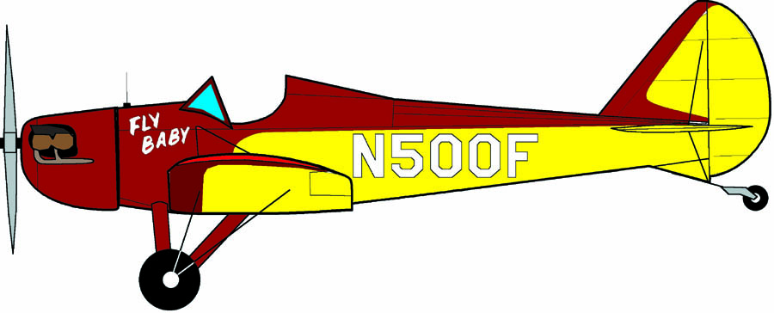

NOTE: This is a template to be used by Fly Baby owners for generation of Operating Handbooks for their specific aircraft. Specification and performance data must be replaced by specific values of the actual aircraft. Similarly, the other material in this handbook must be edited/removed in accordance to its applicability to the actual aircraft. No warranty, expressed or implied, is given regarding the accuracy of the information in this template.

# Table of Contents

Table of Contents 2

1 Specifications 4

2 Performance 5

3 Limitations 6

4 Operating Characteristics 7

4.1 General 7

4.2 Handling and Stability 7

4.3 Airspeed 8

4.4 Stalls 8

4.5 Aerobatics 8

4.6 Pilot Comfort 8

4.7 Fuel Gauge 9

5 Preflight Inspection 10

5.1 Cockpit 10

5.2 Aft Fuselage and Tail 10

5.3 Wings 10

5.4 Landing Gear 11

5.5 Nose, Engine, and Propeller 11

6 Engine Start 12

6.1 When equipped with electrical starter 12

6.2 When not equipped with electrical starter, with someone to turn the propeller for you 12

6.3 When hand-propping yourself 12

7 Before Takeoff 14

7.1 Taxiing 14

7.2 Pre-Takeoff Checklist 14

8 Flight Procedures 15

8.1 Takeoff 15

8.2 Climb 15

8.3 Cruise 15

8.4 Descent 15

8.5 Landing 15

9 Post-Landing 16

10 Weight and Balance 17

11 Emergency Procedures 18

11.1 General 18

11.2 Engine Failures 18

11.2.1 Engine Failure - Complete 18

11.2.2 Engine Failure - Partial 18

11.2.3 Engine Failure Checklist 19

11.3 Flight Control Failure 19

12 Suggested Condition Inspection Checklist 21

# Specifications

|  |  |
| --- | --- |
| Wing Span: | 28 feet |
| Length: | 18 feet 10.5 inches |
| Height: | 6 feet 11 inches (wing folded) |
| Tail Span: | 7 feet 11.5 inches |
| Wing Area: | 120 sq ft |
| Empty Weight: |  |
| Gross Weight: |  |
| Fuel Capacity: |  |

Note: Information provided is generic. Blanks indicate items which must be determined from the actual aircraft.

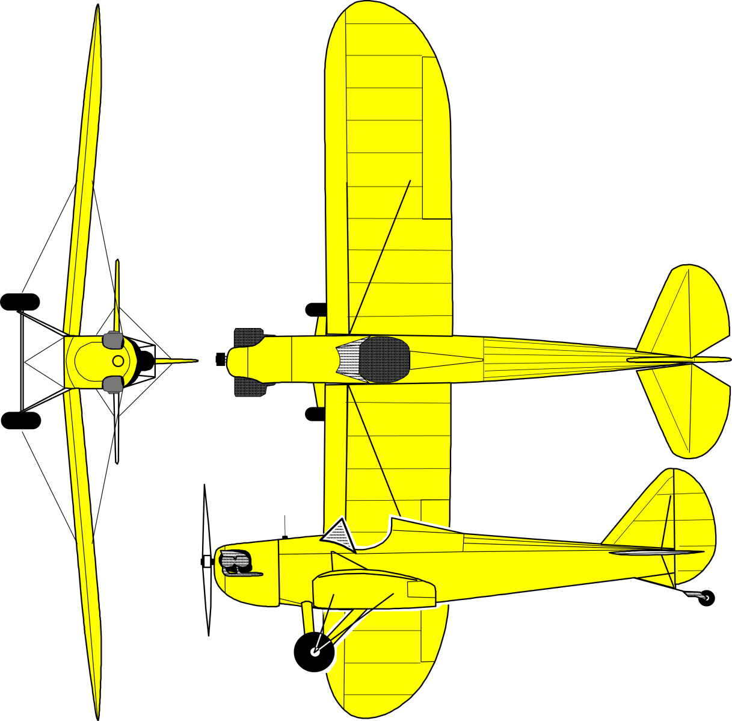

# Performance

|  |  |
| --- | --- |
| Stall Speed: |  |
| Cruising Speed: |  |
| Rate of Climb |  |
| Best Rate of Climb Speed: |  |
| Best Angle of Climb Speed: |  |
| Range: |  |
| Takeoff Distance |  |
| Takeoff over 50’ Obstacle: |  |
| Landing Distance: |  |
| Landing over 50’ Obstacle: |  |
| Fuel Capacity: |  |

Note: Information in this section must be determined from flight tests of the actual aircraft.



# Limitations

1. This aircraft is licensed as an Experimental Amateur-Built aircraft, and must comply with the limitations of its certification category
2. Aerobatic maneuvers are prohibited
3. Any major change to the aircraft, as defined in 14CFR 21.93, invalidates the Special Airworthiness Certificate issued to the aircraft.
4. This aircraft shall not be used for glider towing operations
5. No person shall operate this aircraft unless, in the preceding 12 calendar months, it has received a conditional inspection with the scope and breadth of 14CFR Part 43 Appendix D.

Note: Replace the above information, as necessary, with the contents of the Operating Limitations for the actual aircraft.

# Operating Characteristics

The following section consists of material to familiarize new Fly Baby pilots with the operation and handling of the aircraft. It assumes that the aircraft is correctly rigged, and is flown with the CG in the correct range.

## General

The Fly Baby is a conventional-gear (taildragger) aircraft, and its air and ground handling is similar to common classic taildragger aircraft such as the J-3 Cub or Aeronca Champ.

Depending upon the height of the pilot and the design of the seat, visibility over the nose may be obstructed. In these cases, performing gentle S-turns while taxiing should allow sufficient forward visibility.

Between a combination of tailwheel spring stiffness, tire condition, tire inflation, temperature, and taxi speed, the airplane sometimes starts bouncing up and down on its tires as it taxies along.  This is called the “Dribbles”. It's not dangerous, it doesn't affect control.  If it occurs, just slow down or speed up.

If the aircraft is equipped with a Continental engine, the nose will tend to swing left as the takeoff roll begins. This is easily countered with rudder pedal pressure. New pilots may consider a gradual application of power to minimize the swing.

The pilot should attempt to raise the tail early in the takeoff run to accelerate better and to give visibility over the nose. Depending on the aircraft configuration, the change from tailwheel steering (when the tail is still on the ground) to aerodynamic steering (using the rudder as the tail comes up) may require a slight change in the amount of rudder pedal. In any case, the amount necessary will be decreasing as the aircraft accelerates.

A slight instability may appear around 35 MPH, but the aircraft quickly accelerates through that speed range. However, if a new pilot attempts to practice “high-speed taxiing,” the aircraft may remain in this range and give a false indication of handling problems.

It is recommended that pilots do not perform high-speed taxi testing, unless there is a specific issue that needs to be addressed.

## Handling and Stability

The Fly Baby has generous dihedral, and is very stable in yaw and roll. Stick pressures are very light, but good feedback is provided. Little actual stick movement is necessary in normal flight; it’s likely the stick will not move more than two inches from the neutral position.

However, this does not mean the aircraft will maintain level flight with the stick released. The aircraft does not include any offset in the vertical stabilizer to compensate for engine P-factor, so the airplane will have a tendency to yaw. An external, fixed trim tab is recommended on the rudder.

Also, if the wing rigging is not perfect, the aircraft will have a tendency to drop a wing and start turning if the stick is released. If the rigging is good enough, this is easily compensated for.

The ailerons should include gap seals; if omitted, the plane may be slightly more sluggish in roll.

Fly Baby stick forces are moderate in roll, but extremely light in pitch. Enough stick motion is necessary that the control does not feel overly sensitive.

Stock Fly Babies do not have cockpit-adjustable pitch trim. Control forces are light enough that it is not needed. An external tab should be installed on the elevator, and adjusted to the pilot’s desires. The ideal situation is adjusting the trim so that no elevator pressure is necessary at cruise with half a tank of fuel. This way, the airplane is slightly nose heavy with a full tank, but slightly tail-heavy as the fuel level drops. Again, this is easily compensated for.

## Airspeed

With open cockpit and a network of external bracing wires, the Fly Baby is a high-drag, low-inertia aircraft. When power is reduced, airspeed drops quickly. In the event of an engine failure, the pilot should be prepared to add forward stick immediately to maintain flying speed.

Excellent audible feedback is received from the sound of the slipstream through the landing wires. However, the landing wires (the ones on the top of the wing) may “shiver” a bit in flight. This is normal, since the load disappears completely from the landing wires as the flying wires below wings support the aircraft in positive G flight.

## Stalls

Stalls in a Fly Baby are conventional, and proceeded by airframe buffeting.

If the aircraft is properly rigged and rudder is neutral, the stall break should be straight-ahead. However, due to the drag of the aircraft, the break will likely be more abrupt than a typical training aircraft. The nose will drop significantly at the break…again, easily controlled once a bit of airspeed is regained.

If the airplane is cross-controlled at the break, a wing will drop. This is easily recovered using rudder. The aircraft does not have a tendency towards spinning, but roll control at the stall should be limited to rudder.

Spin recovery, should one occur, is conventional.

## Aerobatics

The Fly Baby is a personal sport aircraft, and it is recommended that aerobatics not be performed. One example of the airframe has been tested to +6 to -3 Gs without deformation, but variance in built quality will affect the ability of a given aircraft to withstand the stresses of aerobatics.

## Pilot Comfort

As an open-cockpit airplane, the pilot’s personal environment depends on his or her clothing. Discomfort may affect safety; a chilled pilot is a distracted pilot.

The Fly Baby stock cockpit and windshield do very well at protecting the pilot from the slipstream and drafts, but the fact is that ambient air will be moving across the pilot’s body to some extent.

Every person has different tolerance for physical conditions. The following table can be used as a guideline for new Fly Baby pilots. This is a guide; notice that there is some overlap, depending on personal tolerance.

|  |  |  |  |  |  |  |  |  |
| --- | --- | --- | --- | --- | --- | --- | --- | --- |
| **Suggested Equipment** | **Temperature Range (ºF)** | | | | | | | |
| >90 | 80 to 90 | 70 to 80 | 60 to 70 | 50 to 60 | 40 to 50 | 30 to 40 | <30 |
| Street clothes | X |  |  |  |  |  |  |  |
| Leather Helmet |  | X | X | X | X | X | X | X |
| Light Jacket |  |  | X | X |  |  |  |  |
| Gloves |  |  |  |  | X | X | X | X |
| Scarf |  |  |  |  | X | X | X | X |
| Leather Coat (A-2/G-1) |  |  |  |  | X | X | X | X |
| Sweatshirt |  |  |  |  |  | X | X | X |
| Face Mask |  |  |  |  |  | X | X | X |
| Insulated Underwear |  |  |  |  |  |  | X | X |
| Heavy Leather Coat  (B-3/Irvin |  |  |  |  |  |  | X | X |

## Fuel Gauge

The Fly Baby uses a J-3 Cub fuel indicator; a cork floating on the fuel, with a wire sticking out the cap to indicate fuel level. Slipstream forces can tend to pin the wire to the sleeve in the cap, and delay its movement down as the fuel is used. This can cause an unexpected sudden drop in fuel level when the cork and wire suddenly “unstick.”

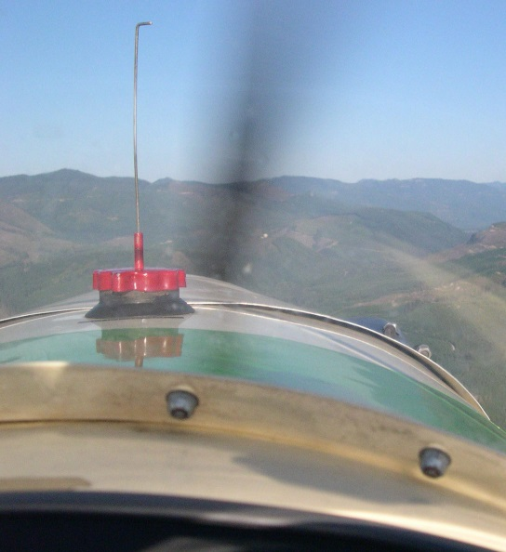Periodic wiping of the wire with oil is a good preventative. However, the best way to avoid fuel exhaustion is awareness of the pre-flight fullness of the tank, and the amount of time the aircraft has flown.

# Preflight Inspection

Note: The following information is provided as a starting point for the owner to develop his or her own checklists. This checklist emphasizes Fly Baby-specific items during pre-flight; there are other actions which are generic to aircraft pre-flight inspections. The owner should add these items as appropriate.

## Cockpit

* Seat secure, in position
* Shoulder harness draped across outside of turtledeck (to facilitate cockpit entry)
* Seat belts clear of rudder cables, draped diagonally across front of seat
* Spar pins in place
* Elevator pushrod attach bolt secure
* Aileron pushrods connected, with safety pins in place.
* Seatback and cockpit equipment clear of elevator walking beam behind seat
* Turtledeck latches secure
* Magneto Switch -- OFF
* Radio – OFF
* Transponder - OFF
* Master Switch -- OFF
* Carb Heat – COLD
* Required documentation -- Available In Airplane

## Aft Fuselage and Tail

* Surface check of Fuselage and tail
* Tail bracing cables, turnbuckles, and anchors
* Check hinges in elevators and rudder
* Elevator bolts in place
* Check the differential play in elevators
* No cracks/tears in tailwheel horn
* Shake tail slightly side-to-side, watching the motion of the tailwheel.  Look for side-to-side play around the tailpost mounting

## Wings

* Landing wires attached to anchors
* No distortion in fabric around landing wire/flying wire anchors
* Close examination of flying wire anchor plates (cracks, bends, nuts in place, etc.)
* "Plunk" both forward flying wires to see if they're about the same tension
* Check turnbuckles, cables, and arrow
* Check cables at wheel shackle...no fraying, kinking, etc.
* Check Aileron for security and travel (note: the Aileron system has more upward travel than downward).
* Check Aileron gap seal for security
* Check Aileron pushrod
* Pitot/Static boom: Undamaged, no obstructions

## Landing Gear

* Flying-wire attachment shackle undamaged
* Flying Wire attachment clevis pin in place and safetied
* No sign of degradation (loops, fraying, etc.) on flying wires
* Landing-Gear cross-brace cables, turnbuckles, and attach points
* Make sure wheel-attach bolts are in place
* Tire has proper inflation
* Brakes normal

## Nose, Engine, and Propeller

* Oil Level – 3 quarts or higher
* Propeller secure, no damage
* Cowling secure
* Spark Plug wires secure
* Front Air Intake clear
* Carburetor heat intake secure
* Exhaust system - Secure
* Fuel cap – secure
* Fuel indicator – cork floating, wire moves smoothly in cap

# Engine Start

## When equipped with electrical starter

* Seat Belts/Shoulder Harness attached
* Master Switch: ON
* Radio/Transponder: OFF
* Throttle: Idle or slightly cracked
* Carburetor Heat: OFF
* Mixture: RICH
* Magneto Switch: BOTH *
* Primer: AS REQUIRED
* Primer: SECURED
* Brakes: SET
* Propeller Area: CLEAR
* Starter: ACTIVATE
* Oil Pressure: In the green arc within 30 seconds

## When not equipped with electrical starter, with someone to turn the propeller for you

* Brief the person on procedure and terminology
* Seat Belts/Shoulder Harness attached
* Throttle: Idle or slightly cracked
* Carburetor Heat: OFF
* Mixture: RICH
* Magneto Switch: OFF
* Primer: AS REQUIRED
* Primer: SECURED
* Brakes: SET
* Call: SWITCH OFF
* Have the person turn the engine over four blades
* Ensure the helper is clear of the propeller arc
* Call: CONTACT
* Magneto Switch: BOTH *
* Helper: Turn engine over
* On engine start, the oil pressure should be in the green arc within 30 seconds

## When hand-propping yourself

* Wheel chocks in place
* Tail tied to solid object
* Seat Belts/Shoulder Harness ready for donning
* Throttle: Idle or slightly cracked
* Throttle lock: TIGHT
* Carburetor Heat: OFF
* Mixture: RICH
* Magneto Switch: OFF
* Primer: AS REQUIRED
* Primer: SECURED
* Turn the engine over four blades
* Throttle: Verify position
* Magneto Switch: BOTH *
* Prop engine until it starts
* Throttle: Idle
* Go to left wing tip, walk inboard to wheel. Keep within touching distance of wing leading edge
* Remove left chock, back away from fuselage until clear
* Go to left wing tip, walk inboard to wheel
* Remove right chock, , back away from fuselage until clear
* Note engine RPM, if engine has picked up, return to cockpit position to adjust throttle.
* Untie tail tiedown
* Climb into cockpit
* Brakes: Set
* Seat Belt/Should Harness: Attach

* Magneto to “both” if both mags have impulse coupling. If only one has an impulse coupling, the mag switch should be set to only that magneto for starting.

# Before Takeoff

## Taxiing

Depending upon the seat position and the height of the pilot, minor S-turns may be necessary to see forward.

Between a combination of tailwheel spring stiffness, tire condition, tire inflation, temperature, and taxi speed, the airplane sometimes starts bouncing up and down on its tires as it taxies along.  It's not dangerous, it doesn't affect control.  If it occurs, just slow down or speed up.

## Pre-Takeoff Checklist

* Controls free
* Drop hand along seat belts, ensure they are clear of rudder cables
* Goggles down
* Scarf secure
* Jacket zipped
* Shoulder harness strap ends secured
* Nearby small children waved at
* Altimeter: SET
* Radio: SET
* Transponder: ON/ALT
* Brakes: SET
* Mixture: RICH
* Throttle: 1800 RPM
* Magneto Check
* Carb Heat check
* Throttle: Idle

# Flight Procedures

## Takeoff

* Position aircraft on centerline
* Center rudder and ailerons
* Elevator: SLIGHTLY FORWARD
* Throttle: Full
* Verify normal RPM achieved (typically 2100-2300 RPM, depending on engine and propeller).
* Aircraft with Continental engines will need right rudder to track straight
* Raise tail when controllability gained. Note that the amount of rudder pedal pressure needed to track straight may change slightly when the tail comes up.
* Rotate at 1.2 VSO

## Climb

Typical climb is at 1.3 VSO… typically 65-70 MPH, however, actual displayed airspeed may vary by aircraft.

For most pilots, setting the horizon atop the fuel cap gives approximately the right climb angle (may vary by pilot height and seating position).

## Cruise

Cruise RPM will vary by engine….2150 RPM for A65s, to 2400 RPM for C85s.

## Descent

All power reductions on Continental engines should be preceded by carburetor heat.

## Landing

* Mixture: RICH
* Carburetor heat: ON
* Power to ~1800 RPM abeam the numbers
* Approach speed 70-80 MPH (depending on airspeed indicator calibration)
* Reduce power to 1500 on turning final
* Power to idle as runway is made
* Slip as needed to eliminate excess altitude
* Fly the airplane to contact due to stiff landing gear

# Post-Landing

* Taxi clear on runway
* Goggles: UP
* Transponder: OFF or STANDBY
* Taxi to desired location
* Radio: OFF
* Transponder: OFF
* Throttle: IDLE
* Magnetos: OFF (aircraft with other than Stromberg carburetors may stop the engine by going to full lean on the mixture).

# Weight and Balance



**Allowable CG Range: 26 to 32 Inches Aft of Datum**

Owner should insert specific CG information for his or her aircraft.

# Emergency Procedures

## General

The Bowers Fly Baby is a conventional aircraft, and standard emergency procedures will suffice. The following sections provide insight into how unique features of the Fly Baby may affect standard procedures.

## Engine Failures

As ever, if the engine fails, the aircraft should be configured for an emergency landing prior to attempting in-air troubleshooting.

Due to the high drag of the Fly Baby airframe, the glide angle in an engine-out situation is fairly steep. If the engine fails, the pilot should be cautious not to select an emergency landing field too far away.

Engine failures can be complete or partial.

### Engine Failure - Complete

Due to the simplicity of the systems on a stock Fly Baby, complete engine failure is generally due to either fuel management or mechanical problems with the carburetor.

Too often, a complete engine failure is due to fuel exhaustion…the pilot runs out of gas.

Fuel Starvation is a possibility as well…having fuel on board, but the flow, for some reason, has been interrupted. Stock Fly Babies have a single fuel valve for controlling gasoline flow to the engine; in the event of a complete failure, the position of this valve should be checked. However, the stock position is generally clear of any inadvertent movement that might accidentally change the position of the valve.

Mechanical issues with the carburetor are usually not fixable in flight. These might include disconnection of the throttle cable or carburetor heat cable from the carburetor, or internal problems with the carburetor itself. Once established on a glide to a safe landing area, the pilot may manipulate engine controls (mixture, etc.) to attempt to regain some power. However, remember the overwhelming goal is a safe landing…don’t let a temporary restoral of power lure you away from a good landing spot.

### Engine Failure - Partial

Most of the same problems that may cause complete engine failures may cause partial failures.

However, with a Continental engine, the first step upon detection of loss of power should be the application of carburetor heat. The small 4-cylinder Continentals are prone to carburetor ice. Remember that the application of carburetor heat may cause considerable roughness in engine operation as the ice is melted away and sucked into the engine. If you think there is icing, turn carb heat on and leave it on…don’t immediately turn it off if the engine starts to stagger. Give it time to work.

Conceivably, magneto failure can cause significant engine roughness. If the timing of one of the magnetos slips, it may prematurely fire the fuel in the cylinders. After turning on the carburetor heat, the next step is to perform an ordinary magneto check. If the engine returns to near-normal running on one magneto, continue to operate on it to the nearest airport.

### Engine Failure Checklist

Complete or partial engine failure, pilot reaction should be about the same:

* Carburetor Heat: ON
* Throttle: FULL
* Assume best glide airspeed (typically 65-70 MPH)
* Select landing location. Remember the Fly Baby glides steeply with the engine off
* Mixture: RICH
* Fuel valve: ON
* Magneto: LEFT
* Magneto: RIGHT
* Magneto: BOTH (assuming the check found no problems)
* If engine windmilling:
  + Throttle: IDLE
  + Throttle: ½ Full
  + Mixture: Full Lean
  + Mixture: Half rich
* If time permits:
  + Radio: MAYDAY
  + Transponder: 7700
* If Emergency landing is inevitable:
  + Fuel valve: OFF
  + Magneto: OFF
  + Throttle: IDLE
  + Master switch: OFF
  + Shoulder harness/Lap Belt: AS TIGHT AS POSSIBLE

## Flight Control Failure

There have been few cases of failures of Fly Baby flight controls. Here are some recommendations if one occurs:

Ailerons: Both ailerons are independently operated by pushrods connected to the control stick. If one aileron pushrod becomes disconnected, the other one would still work.

If a pushrod becomes disconnected, it is recommended that left-right stick movement be minimized to reduce the chance of a loose rod end jamming in structure.

Rudder: There have been a case of a rudder pedal becoming disconnected from the rudder cable (maintenance issue; wrong type of connector used). If this occurs, remember that the rudder cables themselves go past the pilot seat near the cockpit floor. It is possible to grab a lose cable and apply some pressure as needed.

Elevators: There have been no known cases of elevator control failure. Since the Fly Baby does not have a cockpit-adjustable pitch trim, this backup method of control is not available. The Fly 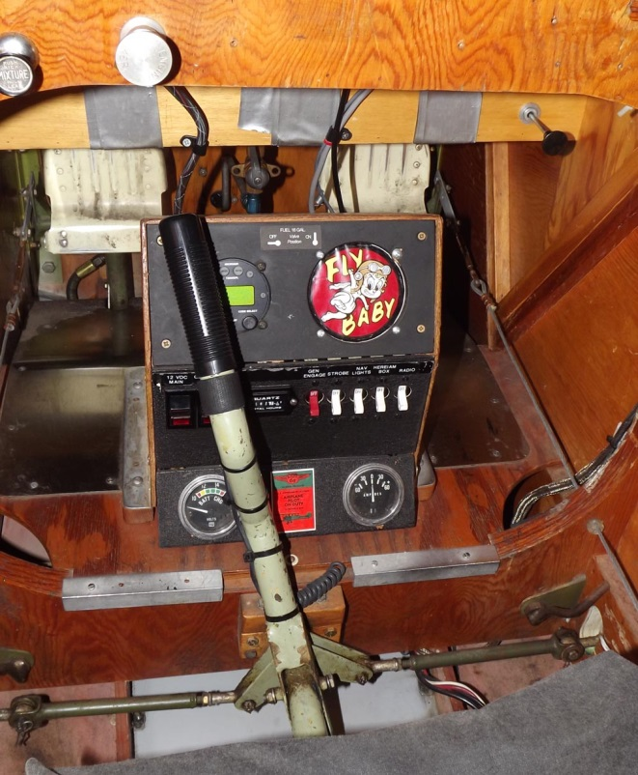Baby pitch attitude is sensitive to power settings, though, so the pitch attitude could be roughly controlled by throttle position.

Jammed Stick: The stock Fly Baby cockpit does not present a major hazard that a dropped piece of equipment (such as a glove) may jam the stick. Stock Fly Babies do not have a cockpit floor in the area forward of the seat, so jams are unlikely. However, some builders do add a floor in this area. If your aircraft has one, add a conical cover around the opening to minimize the chances of a dropped item jamming the stick.

# Suggested Condition Inspection Checklist

*Based on 14 CFR Part 43 Appendix D*

(a) Remove or open all necessary inspection plates, access doors, fairings, and cowling.

(1) Thoroughly clean the aircraft and aircraft engine.

(b) Inspect the following components of the fuselage:

(1) Fabric and skin—for deterioration, distortion, other evidence of failure, and defective or insecure attachment of fittings, fabric drain holes clear.

(2) Systems and components—for improper installation, apparent defects, and unsatisfactory operation.

(3) Security of turtledeck

(c) Inspect the following components of the cockpit:

(1) Generally—for uncleanliness and loose equipment that might foul the controls.

(2) Seats and safety belts—for poor condition and apparent defects.

(3) Windshield—for deterioration and breakage.

(4) Instruments—for poor condition, mounting, marking, and (where practicable) improper operation.

(x) Master turnbuckle:

(i) Correctly tensioned and safetied

(ii) All related clevis pins safetied

(5) Flight and engine controls—for improper installation and improper operation.

(i) Control stick welds—condition and security

(ii) Aileron pushrods—condition and proper attachment of safety pins

(iii) Elevator pushrod—condition and security

(iv) Elevator walking beam—security and condition

(v) Rudder pedals—security and condition

a) Rudder cables- turnbuckles and cable attachment to the pedals.

(vi) Brake system—condition, improper inspection, brake-fluid level and potential brake-fluid leaks.

(vii) Engine controls – secure with smooth operation

(6) Proper installation and safetying of the spar pins

(i) Examine the condition of the attachment points on the STA 3 and STA 5 bulkheads

(7) All systems—for improper installation, poor general condition, apparent and obvious defects, and insecurity of attachment.

(8) Cockpit fuel system - for leaks and security

(i) Fuel tank - firmly strapped and no leaks

(ii) Shut-off valve – smooth operation and no leaks

(iii) Fuel hose – abrasion-free and no leaks

(9) Cockpit structure:

(i) Security and lamination of the bolted firewall to angle-bracket union

(ii) Lamination of the station 1 to 2 and lower fuselage-side “double truss” box sections

(iii) Security of the lower fuselage boxed longitudinal supports for floor boards and seat

(10) Seat – for condition and security

(d) Inspect components of the engine as follows:

(1) Engine section—for visual evidence of excessive oil or fuel leaks, and sources of such leaks.

(2) Studs and nuts—for improper torquing and obvious defects.

(3) Internal engine—for cylinder compression and for metal particles or foreign matter on screens and sump drain plugs. If there is weak cylinder compression, for improper internal condition and improper internal tolerances.

(4) Engine mount—for cracks, looseness of mounting, and looseness of engine to mount.

(5) Flexible vibration dampeners—for poor condition and deterioration.

(6) Engine controls—for defects, improper travel, and improper safetying.

(7) Lines, hoses, and clamps—for leaks, improper condition and looseness.

(8) Exhaust stacks—for cracks, defects, and improper attachment.

(9) Propeller—for cracks, nicks, and bends

(i) Propeller Bolts—for improper torquing and lack of safetying.

(10) Accessories—for apparent defects in security of mounting.

(11) All systems—for improper installation, poor general condition, defects, and insecure attachment.

(12) Cowling—for cracks, and defects.

(e) Inspect the following components of the landing gear group:

(1) All units—for poor condition and insecurity of attachment.

(2) Tires—for wear, cuts and improper pressurization

(3) Vee Struts—for damage, delamination, or missing nuts.

(4) Cross-bracing—for tension and proper safetying of turnbuckles

(5) Hydraulic lines—for leakage.

(6) Wheels—for cracks, defects, and condition of bearings.

(7) Master Axle – for bends, cracks, or visual deformation

(8) Brakes—for improper adjustment.

(f) Inspect all components of the wing for poor general condition, fabric or skin deterioration, distortion, evidence of failure, and insecurity of attachment, fabric drain holes clear.

(1) Flying and landing wire attachment plates—condition, cracks, and bends

(2) Flying and landing wire turnbuckles—condition, tension, and safety-wiring

(3) Flying wire shackle—distortion, or flaws in the attachment of the flying wires

(4) Landing wire terminals on the fuselage—distortion, or flaws in the attachment of the landing wires

(5) Master Turnbuckle—tightness safety-wire (or equivalent)

(6) Compression ribs—proper installation and condition

(7) Drag/anti-drag wires: for tension and turnbuckle safety wire

(8) Areas for particular attention when inspecting for water-related deterioration/damage:

(i) Forward of after spar at wing root

(ii) Wing wire junction blocks (both water damage and delamination)

(iii) Forward side of aileron spar

(7) Aileron bellcranks—proper installation and condition.

(8) Pitot boom—attachment and proper security

(i) Pitot and static lines—proper attachment

(g) Inspect all components and systems that make up the complete empennage assembly for poor general condition, fabric or skin deterioration, distortion, evidence of failure, insecure attachment, improper component installation, and improper component operation. Ensure water not collecting in compartment forward of tailpost, fabric and other water drain holes clear.

(1) Bracing wires—for proper tension

(2) Turnbuckles—for proper safetying

(3) Tailspring attach brackets—for condition and solid attachment

(4) Rudder and tailwheel control horns—for bends and cracks

(5) Tailwheel assembly—general condition

(6) Tailwheel spring – security and condition

(7) Tailpost: condition at lower tailpost to tailwheel bracket union

(h) Inspect (where applicable) the following components of the radio group:

(1) Radio and electronic equipment—for improper installation and insecure mounting.

(2) Wiring and conduits—for improper routing, insecure mounting, and obvious defects.

(3) Bonding and shielding—for improper installation and poor condition.

(4) Antennas—for poor condition, insecure mounting, and improper operation.

(i) Inspect (where applicable) each installed miscellaneous item that is not otherwise covered by this listing for improper installation and improper operation.